**Department of Computer Science and Engineering**

|  |  |
| --- | --- |
| **Course Code: CSE341** | **Credits: 1.5** |
| **Course Name: Microprocessors** | **Semester: Fall’18** |

**Lab 10  
Introduction to EMU8086 Kit**

1. **Topic Overview:**

This lab will make students acquainted with the basics of an EMU/MDA8086 Trainer Kit and its components. The students will have hands on knowledge on how to configure the above mentioned kit using “Machine Code” mode.

1. **Lesson Fit:**

None

1. **Learning Outcome:**

After this lecture, the students will be able to:

* 1. Have a clear knowledge on the basic structure of EMU/MDA8086 Trainer Kit.

1. **Anticipated Challenges and Possible Solution.**

None Yet.

1. **Acceptance and Evaluation**

Students will show the problems to the instructor one by one after completion. Those who won’t be able to finish the assigned tasks in time will show them in the next class. There will be a short viva for the students who will show the finished tasks on the next day to check if they completed the tasks by themselves. A deduction of 30% will be there for late submission. The marks distribution is as follows:

Code: 50%

Viva: 50%

1. **Activity Detail**
   1. **Hour: 1 & 2 & 3  
      Discussion: Introduction to EMU/MDA8086 Trainer Kit**MDA-8086, is a kit having 8086 as a central processing unit and various other components (memories, I/O, buses) etc. for the detailed understanding of 8086 microprocessor.  
      Function of ICs at Figure 1 (Next Page):
      1. CPU (Central processing unit): Using Intel 8086, Using 4.9152Mhz.
      2. ROM (Read Only Memory): It has program to control user's key input, LCD display, user's program. 64K Byte, it has data communication program. Range of ROM Address is F0000~FFFFFH.
      3. SRAM (Static Random Access Memory): Input user's program & data. Address of memory is 00000H~0FFFFH, totally 64 KByte .
      4. DISPLAY: It is LCD, 16(Character) × 2(Line).
      5. KEY BOARD: It is used to input machine language and has 16 of hexa-decimal keys and 8 of function keys.
      6. SPEAKER: Able to test sound using with speaker and further more able to test synthesizer.
      7. RS-232C: For data communication with IBM compatible computers.
      8. DOT MATRIX LED: To understand & test of dot matrix structure and principle of display it is interfaced to 8255A (PPI).
      9. A/D CONVERTER: Convert analog to digital signal using ADC0804.
      10. D /A CONVERTER: Convert digital signal to analog signal using with DAC0800 and it is interfaced so as to more Level meter.
      11. STEPPING MOTOR INTER FACE: So as to control stepping motor driver circuit of stepping motor is interfaced.
      12. POWER: AC 110~220V, DC +5V 3A, +12V 1A , -12V 0.5A SMPS.

**MDA-8086 System Configuration:**

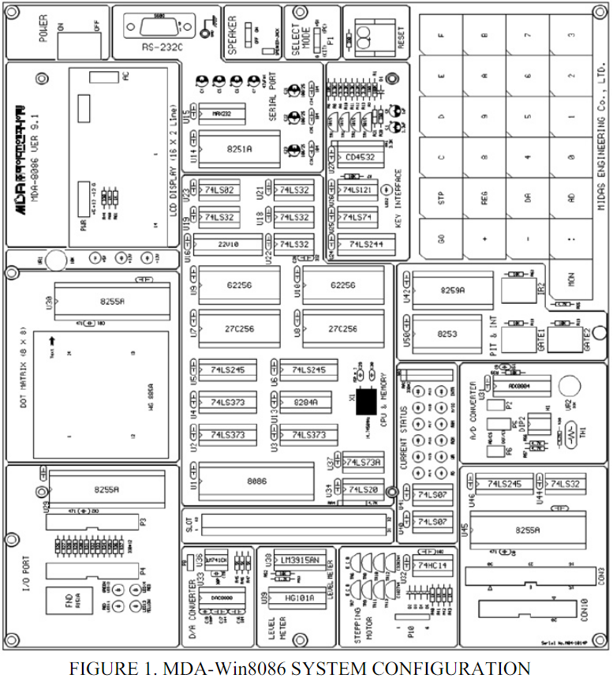

**Memory map:**

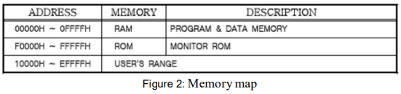

**I/O Address Map:**

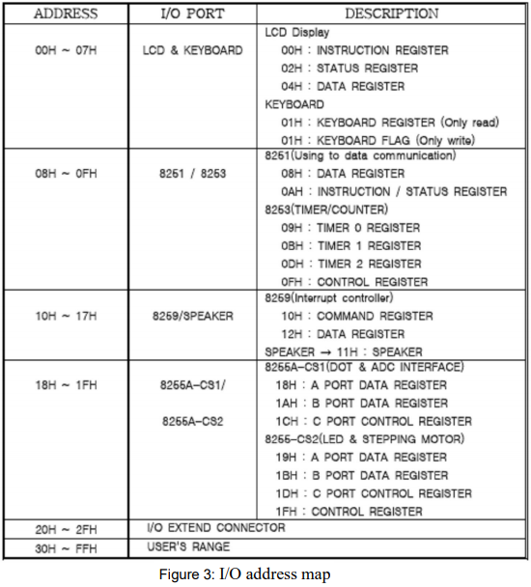

**Kind and Function of Keys**

MDA-8086 has high performance 64K-byte monitor program. It is designed for easy function. After power is on, the monitor begins to work. In addition to all the key function the monitor has a memory checking routine.

The following is a simple description of the key functions.

